1. Click “Add Site”. The Add Site dialog opens.
2. Set the Name to “Force.com IDE” and the Location to “<http://media.developerforce.com/force-ide/eclipse42>“, then click “OK.”

[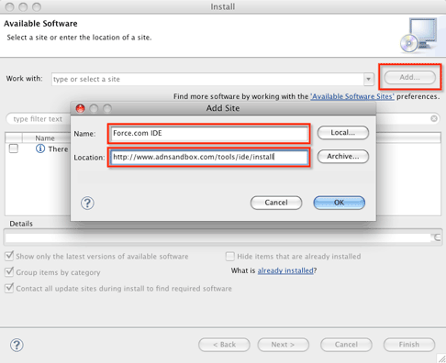](https://jitendrazaa.com/blog/wp-content/uploads/2010/09/Eclipse_addsite_486w.png)

After you add the site, you will get the list of all available plugins, click on **force.com** and then click Next.

In the Install dialog, click “Next” then accept the terms and click.

[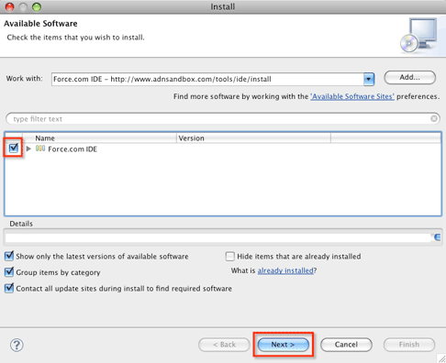](https://jitendrazaa.com/blog/wp-content/uploads/2010/09/Eclipse_checkandnext_486w.png)

follow the instructions and IDE will be installed.

After Installation, Create new Project of type **Force.com**.

[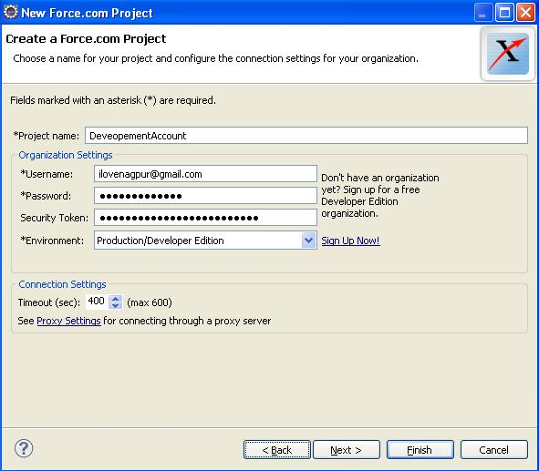](https://jitendrazaa.com/blog/wp-content/uploads/2010/09/Setup-Salesforce-Account.jpg)

As You can see in above snap following details needed while creating the salesforce project.

* Salesforce UserName
* Salesforce Password
* Salesforce Security Token

### How to generate secret key

#### Where can I find or view my Salesforce security token?

As mentioned above, Salesforce doesn’t actually let a user view their security token within the application. To gain access to your security token, go to “Setup” (appears in the top right corner, under your name).

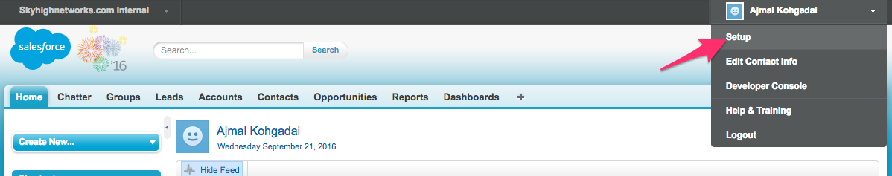

In the left side menu column (under Personal Setup), open the drop down item “My Personal Information.” The option to reset your security token will appear right under password reset option.

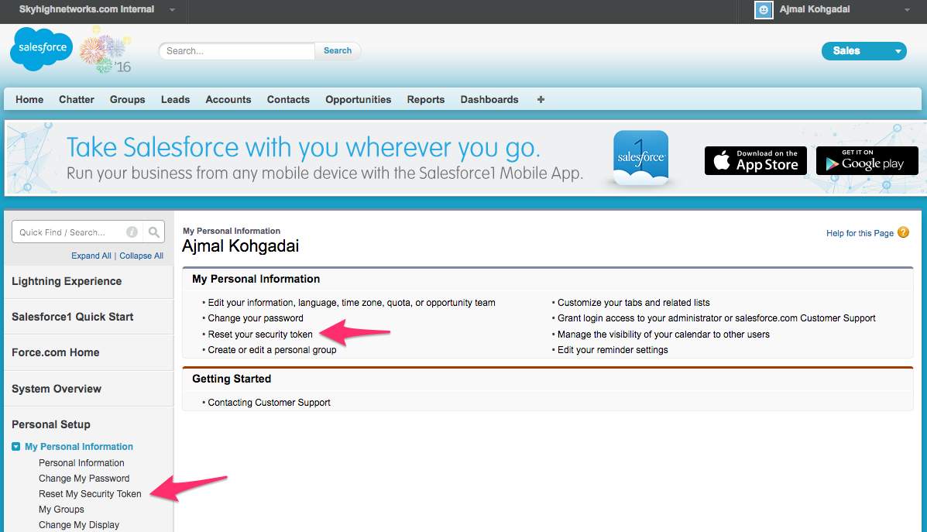

Salesforce will send you an email containing your new security token. It’s recommended that you save this email in a secure location so that you don’t have to reset your security token every time you need it.

for (APEX_Customer__c objCustomer: Trigger.new) {

if (objCustomer.APEX_Customer_Status__c == 'Active') {

APEX_Invoice__c objInvoice = new APEX_Invoice__c();

objInvoice.APEX_Status__c = 'Pending';

InvoiceList.add(objInvoice);

}

}

// DML to insert the Invoice List in SFDC

insert InvoiceList;

}

### Explanation

**Trigger.new** − This is the context variable which stores the records currently in the trigger context, either being inserted or updated. In this case, this variable has Customer object's records which have been updated.

There are other context variables which are available in the context – trigger.old, trigger.newMap, trigger.OldMap.

What is Deployment in SFDC?

Till now we have developed code in Developer Edition, but in real life scenario, you have to do this development in Sandbox and then you might need to deploy this to another sandbox or production environment and this is called the deployment. In short, this is the movement of metadata from one organization to another. The reason behind this is that you cannot develop Apex in your Salesforce production organization. Live users accessing the system while you are developing can destabilize your data or corrupt your application.

### Force.com Eclipse IDE

**Step 1** − Open Eclipse and open the class trigger that needs to be deployed.

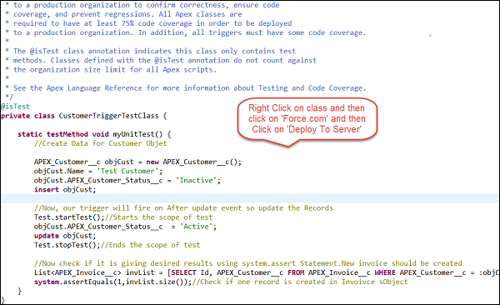

**Step 2** – Right click on class file – then force.com – then click on 'Deploy to server', then enter the username and password of the organization wherein, the Component needs to be deployed.

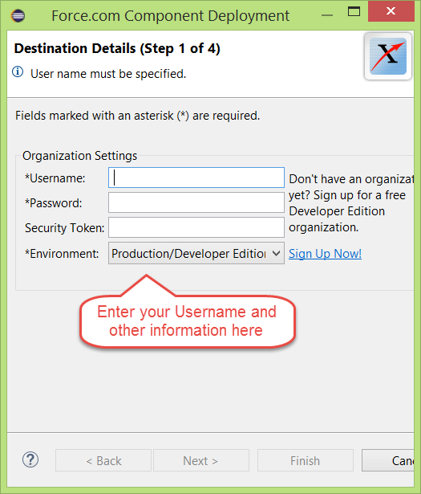

By performing the above mentioned steps, your Apex components will be deployed to the target organization.

## Deployment using Change Set

You can deploy Validation rules, workflow rules, Apex classes and Trigger from one organization to other by connecting them via the deployment settings. In this case, organizations must be connected.

To open the deployment setup, follow the steps given below. Remember that this feature is not available in the Developer Edition −

**Step 1** − Go to Setup and search for 'Deploy'.

**Step 2** − Click on 'Outbound Change Set' in order to create change set to deploy.

**Step 3** − Add components to change set using the 'Add' button and then Save and click on Upload.

**Step 4** − Go to the Target organization and click on the inbound change set and finally click on deploy.

### SOAP API Calls to Deploy

We will just have a small overview of this method as this is not a commonly-used method.

You can use the method calls given below to deploy your metadata.

* compileAndTest()
* compileClasses()
* compileTriggers()

### Force.com Migration Tool

This tool is used for the scripted deployment. You have to download the Force.com Migration tool and then you can perform the file based deployment. You can download the Force.com migration tool and then do the scripted deployment.